COMMON COURSE ASSIGNMENT
CSA0404 – OPERATING SYSTEMS | Covering Process Scheduling, Memory Management & Disk Scheduling

A. Assignment Information
Department | Computer Science and Engineering
Programme | B.E. / B.Tech – CSE
Course Code & Course Name | CSA04 – Operating Systems
Academic Year / Batch | 2026 – 2027
Faculty Name | Dr.Chandravathi
Assignment Title | Design and Implementation of OSLearn – An Interactive OS Algorithm Trainer using Streamlit
Date of Issue | 02/09/2026
Date of Submission | 02/09/2026
Maximum Marks | 100
Course Outcome(s) – CO | CO2, CO3, CO4
Bloom's Taxonomy Level | L3 – Apply, L4 – Analyze, L5 – Evaluate
SDG Mapping (SDG 1–17) | SDG 4 – Quality Education; SDG 9 – Industry, Innovation and Infrastructure
Industry / Societal Relevance | Interactive educational tools improve conceptual understanding of OS algorithms used in real-world servers, cloud platforms, and embedded systems, supporting quality technical education.

B. Assignment Problem / Challenge
This assignment requires students to design, implement, and evaluate an interactive Operating Systems simulator that applies core CSA04 concepts — process scheduling (Units I–II), memory management with paging and page replacement (Unit III), and disk scheduling (Unit IV) — to a unified educational training platform called OSLearn. Students must integrate multiple algorithm families, produce clear comparative visualizations and step-by-step traces, deploy the system as a lightweight web application using Streamlit, validate correctness and usability with sample test cases, and address basic responsible-computing considerations such as transparency of intermediate steps and reproducibility of results.

C. Problem Statement
Scenario: “OSLearn” – Interactive OS Algorithm Trainer
Many students find it difficult to understand how CPU scheduling, page replacement, and disk scheduling algorithms actually work just by reading theory. Your task is to design and implement an interactive educational web application called OSLearn that helps students practice, visualize, and compare these core Operating Systems algorithms through a unified interface.
The system shall integrate three major OS algorithm families:

1. Process Scheduling
Implement FCFS, SJF (Non-preemptive), and Round Robin.
- Users should be able to enter process details (Process ID, Arrival Time, Burst Time, and Time Quantum for Round Robin).
- The system must display a Gantt chart / timeline visualization together with a table showing Waiting Time, Turnaround Time, and Average Waiting/Turnaround Time for each algorithm, enabling side-by-side comparison.

2. Memory Management (Page Replacement)
Implement FIFO and LRU page-replacement algorithms.
- Users will enter the number of frames and a page reference string.
- The system should show the step-by-step frame status after each reference, highlight page faults, and report the total number of page faults for each algorithm so that students can compare performance.

3. Disk Scheduling
Implement FCFS, SSTF, and SCAN.
- Users will enter the disk request queue and the initial head position.
- The system should display the order of servicing (seek sequence) and the total seek time for each algorithm, allowing clear comparative analysis.
Design the application workflow so that user inputs (process lists, reference strings, disk request queues) are processed by the corresponding algorithms and the results are presented as clear tables, Gantt charts, step-by-step traces, and comparative metrics. Develop a clean, simple web interface using Streamlit. Provide 2–3 sample test cases for each module to demonstrate correctness. Optionally, students may add brief natural-language explanations of algorithm steps (no external LLM required).
Evaluate the application under suitable test cases and analyze correctness of algorithm results, usability of the interface, and clarity of visualizations. The completed system should also briefly address responsible-computing considerations including transparency of intermediate simulation steps, reproducibility of results, and educational ethics in presenting algorithm behavior.

D. Requirements and Constraints
- Functional: Provide interactive modules for Process Scheduling (with Gantt charts and timing metrics), Memory Management / Page Replacement (with frame-status traces and page-fault counts), and Disk Scheduling (with seek sequences and total seek times). Accept user inputs as well as sample data. Produce comparative tables, charts, and step-by-step traces.
- Interface: Clean, simple, and user-friendly Streamlit web application with separate pages or clearly separated sections for each module.
- Performance: Simulations must produce correct results with acceptable latency for interactive classroom use and support clear comparative analysis across algorithms.
- Technical constraint: Use Python + Streamlit. No database, no complex architecture, and no mandatory external LLM integration. Open-source tools only.
- Reliability: Algorithm implementations must be correct and reproducible; intermediate steps must be transparent; the system must handle common edge cases without crashing.
- Resource constraint: Project must be completable within the semester timeline using standard student computing resources.
- Responsible Computing: Ensure transparency of simulation steps, reproducibility of results, avoidance of misleading default parameters, and adherence to educational ethics.
- Evaluation & Submission: Test all three modules with sample inputs and show correct results. Submit working Streamlit code, a short report containing sample outputs / screenshots, comparative analysis, and a GitHub repository link.

E.Student Work

1. Problem Understanding and Formulation
1.1 Problem Understanding
Operating Systems contain several algorithms that are essential for managing processes, memory and storage devices. However, understanding these algorithms only through theoretical explanations can be difficult because their execution involves multiple steps and calculations.
The given problem requires the design and implementation of OSLearn, an interactive Operating System algorithm trainer using Python and Streamlit. The system should allow users to enter inputs, execute different OS algorithms and visualize their working through tables, traces and charts.
The application is divided into three major modules:
- Process Scheduling
  - FCFS
  - SJF – Non-Preemptive
  - Round Robin
- Memory Management / Page Replacement
  - FIFO
  - LRU
- Disk Scheduling
  - FCFS
  - SSTF
  - SCAN
The application must calculate appropriate performance measures such as Waiting Time, Turnaround Time, Page Faults and Total Seek Time and present the results clearly for comparison.
1.2 Problem Formulation
The system accepts user input based on the selected algorithm and processes it using the corresponding algorithmic logic.
For process scheduling, the input consists of:
Input | Description
Process ID | Unique identifier of a process
Arrival Time | Time at which process enters the ready queue
Burst Time | CPU execution time required
Time Quantum | Time limit used in Round Robin
For page replacement:
Input | Description
Number of Frames | Number of available memory frames
Page Reference String | Sequence of pages requested
For disk scheduling:
Input | Description
Request Queue | List of disk cylinder requests
Initial Head Position | Starting position of disk head
The output generated by OSLearn includes algorithm results, execution traces, Gantt charts, frame-status tables and seek sequences.

2. Application of Course Knowledge
The project applies concepts from Operating Systems, particularly process scheduling, memory management and disk scheduling.
2.1 Process Scheduling
The scheduling module implements FCFS, SJF and Round Robin algorithms. For each process, the system determines:
- Completion Time
- Waiting Time
- Turnaround Time
- Average Waiting Time
- Average Turnaround Time
A Gantt chart is also generated to visualize CPU execution.
2.2 Memory Management
The memory module implements FIFO and LRU page replacement.
The application displays the frame contents after every page reference and identifies whether the reference results in a page fault.
2.3 Disk Scheduling
The disk scheduling module implements FCFS, SSTF and SCAN.
The application calculates the movement of the disk head between requests and determines the total seek time.
Thus, the project combines theoretical Operating System concepts with practical algorithm implementation.

3. Solution Design and Methodology
The proposed solution follows a modular design where each algorithm is implemented as a separate function.
3.1 Overall Methodology
User Input
↓
Select OS Algorithm
↓
Validate Input
↓
Execute Algorithm
↓
Calculate Performance Metrics
↓
Generate Visualization
↓
Display Results in Streamlit
The application first accepts input from the user. The selected algorithm then processes the input and produces the required results. These results are displayed using Streamlit tables and visualizations.
3.2 Process Scheduling Method
The scheduling module receives process information and applies the selected scheduling algorithm.
For example:
Process Details
↓
Scheduling Algorithm
↓
Completion Time
↓
Waiting Time + Turnaround Time
↓
Gantt Chart + Comparison
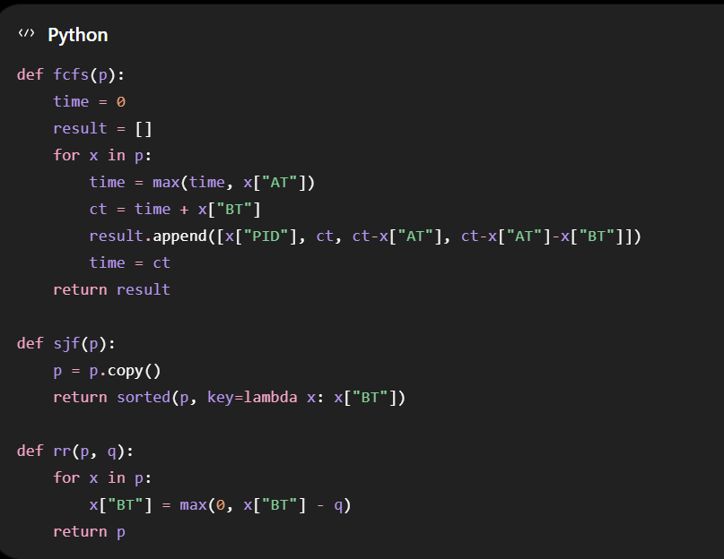
3.3 Page Replacement Method
Reference String + Frames
↓
Page Replacement Algorithm
↓
Check Page
↓
Hit / Page Fault
↓
Update Frames
↓
Display Frame Trace
3.4 Disk Scheduling Method
Request Queue + Head Position
↓
Disk Scheduling Algorithm
↓
Select Next Request
↓
Calculate Head Movement
↓
Update Head Position
↓
Total Seek Time
This modular approach makes the application easier to understand, test and extend.
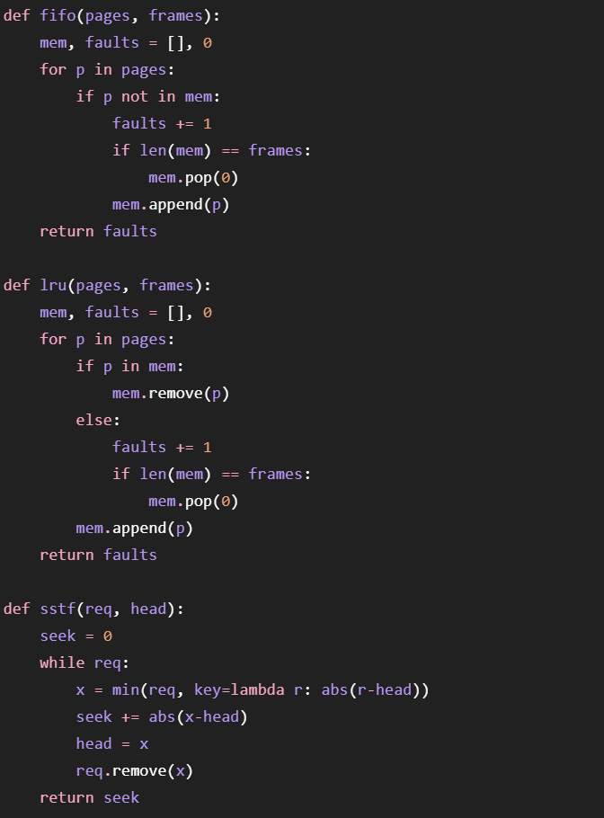

4. Use of Modern Tools
The OSLearn application is developed using Python and Streamlit. Python is used for implementing the Operating System algorithms, while Streamlit is used to create the interactive web interface.
Tools Used
Tool | Purpose
Python | Implementation of OS algorithms
Streamlit | Interactive web application
Matplotlib | Gantt charts and visualizations
Pandas | Tabular presentation of results
GitHub | Source-code management and sharing
The application does not require a database or a mandatory external AI/LLM system. The solution uses open-source tools and focuses on reliable and reproducible algorithm execution.

5. Results and Validation
The implemented algorithms were tested using different sample inputs to verify their correctness.
5.1 Process Scheduling
For process scheduling, the application produces:
- Gantt chart
- Completion Time
- Waiting Time
- Turnaround Time
- Average Waiting Time
- Average Turnaround Time
The results from FCFS, SJF and Round Robin can be viewed side-by-side to understand their performance differences.
5.2 Page Replacement
FIFO and LRU were tested using different page reference strings and frame sizes.
The application displays:
- Page reference
- Current frame contents
- Page hit or page fault
- Total number of page faults
5.3 Disk Scheduling
FCFS, SSTF and SCAN were tested with different request queues and initial head positions.
The application displays:
- Disk request sequence
- Head movement
- Service order
- Total seek time
These tests help verify that the algorithms produce consistent and reproducible results. The assignment specifically requires multiple sample test cases for each algorithm family.
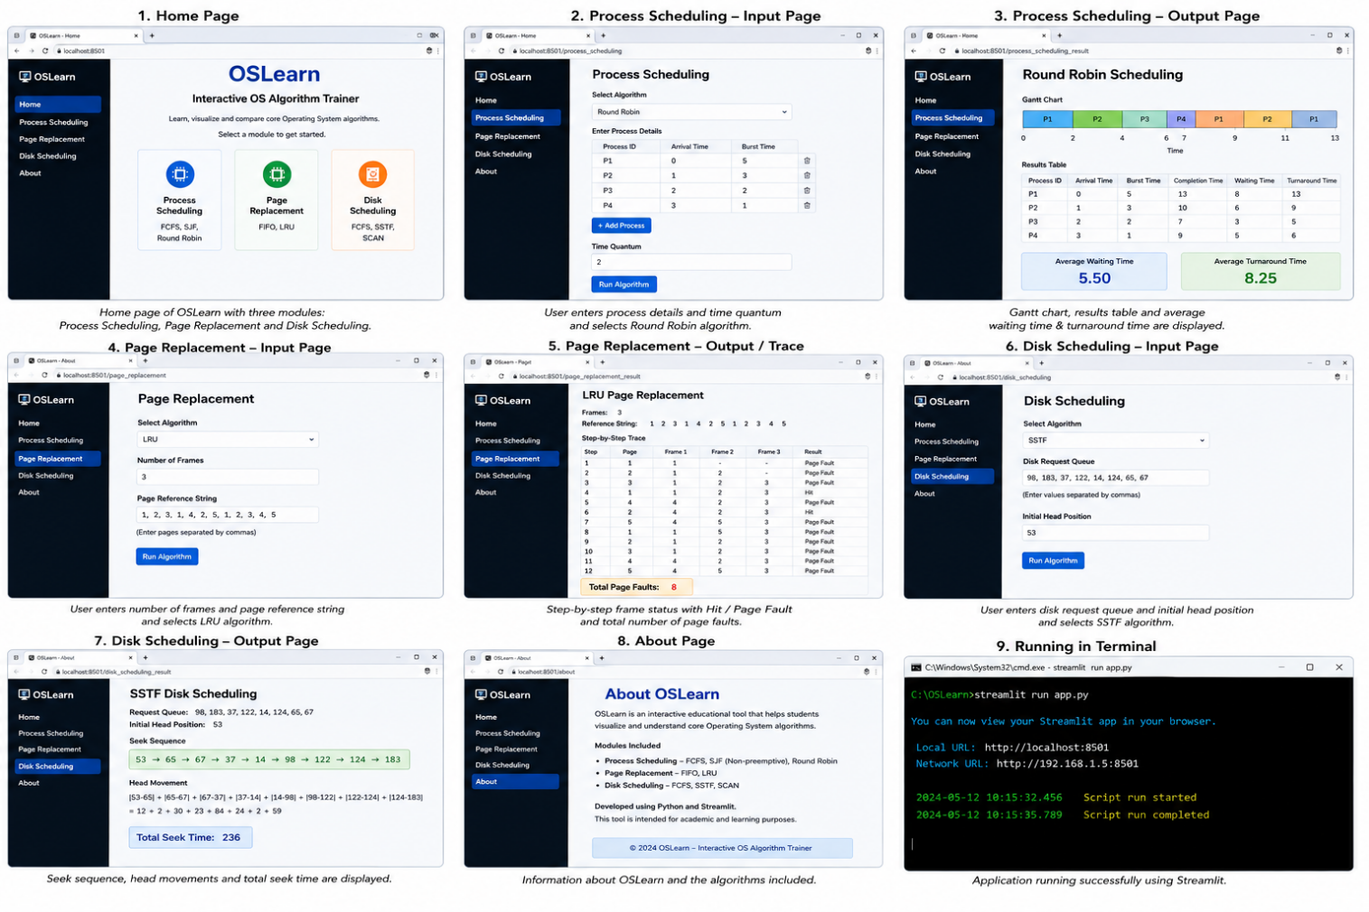

6. Analysis and Engineering Decisions
Different algorithms provide different performance characteristics depending on the input.
Process Scheduling
FCFS is simple and easy to implement but may result in high waiting time when a long process arrives before shorter processes.
SJF generally reduces average waiting time by executing shorter processes first, but longer processes may experience starvation.
Round Robin provides fair CPU allocation because each process receives a fixed time quantum. However, a very small time quantum can increase context switching.
Page Replacement
FIFO is simple because pages are replaced according to their arrival order.
LRU considers recent page usage and can provide better results for reference strings where recently used pages are likely to be reused.
Disk Scheduling
FCFS services requests in their original order and is simple but may result in large head movement.
SSTF selects the closest request and generally reduces seek time, but distant requests may experience starvation.
SCAN moves the disk head in one direction and then reverses direction, providing more predictable servicing.
The application allows these algorithms to be compared visually so that users can understand the trade-offs between simplicity, fairness and performance.

7. Broader Considerations
OSLearn is designed as an educational tool rather than only an algorithm calculator.
The system provides transparent intermediate steps so that users can understand how the final result is obtained. This supports reproducibility and helps students verify their calculations.
The assignment also emphasizes responsible computing through transparency, reproducibility and educational ethics.
The interface should therefore avoid presenting results without explanation and should clearly show the algorithm selected, input values and calculated output.

8. Conclusion
OSLearn provides an interactive platform for learning and understanding important Operating System algorithms.
The system integrates:
- FCFS, SJF and Round Robin for process scheduling
- FIFO and LRU for page replacement
- FCFS, SSTF and SCAN for disk scheduling
Using Python and Streamlit, the application accepts user inputs, executes the selected algorithms and presents the results using tables, traces and visualizations.
The project demonstrates how Operating System concepts can be converted into an interactive educational application while maintaining correctness, usability and reproducibility.

9. Student Reflection
Through this assignment, I gained practical knowledge about implementing Operating System algorithms using Python. I understood how different scheduling, page replacement and disk scheduling algorithms work and how their performance can be compared.
Developing the Streamlit interface also helped me understand how programming concepts can be combined with visualization to create an interactive learning application.
The project improved my understanding of algorithm execution, performance analysis, input validation and user-friendly system design.

10. References
- Operating Systems course materials and lecture notes.
- Python documentation.
- Streamlit documentation.
- Matplotlib documentation.
- Pandas documentation.
- Course assignment specification for OSLearn – An Interactive OS Algorithm Trainer using Streamlit.

F. Common Assessment Rubric
Assessment Criterion | Marks
Problem understanding & formulation | 10
Application of course / domain knowledge (Scheduling, Paging, Disk) | 20
Solution methodology / design / implementation | 20
Use of appropriate modern tools / techniques (Streamlit, Python) | 10
Results, testing & validation | 15
Analysis, trade-offs & justification | 15
Broader considerations / professional responsibility | 5
Technical documentation & reflection | 5
TOTAL | 100

G. CO–PO–Assessment Mapping
Assessment Component | CO | PO(s) | Bloom's Level | Marks
Problem formulation | CO1/CO2 | PO1, PO2 | L3 | 10
Application – Process Scheduling | CO1/CO2 | PO1, PO2, PO3 | L3/L4 | 8
Application – Page Replacement | CO3 | PO1, PO2, PO3 | L3/L4 | 6
Application – Disk Scheduling | CO4 | PO1, PO2, PO3 | L3/L4 | 6
Solution / Design – Integrated OSLearn | CO1–CO4 | PO2, PO3, PO5 | L4/L5/L6 | 20
Modern tool usage (Streamlit / Python) | CO1–CO4 | PO5 | L3 | 10
Validation of results | CO1–CO4 | PO4 | L4/L5 | 15
Analysis & justification / trade-offs | CO1–CO4 | PO2, PO4 | L4/L5 | 15
Broader considerations & documentation / reflection | CO1–CO4 | PO6, PO12 | L3/L4 | 10
Note: PO numbers indicated are illustrative; faculty shall verify against the current CSA04 CO–PO matrix and map only the POs genuinely assessed.

H. Faculty Evaluation & Continuous Improvement

CO Attainment
Performance Level | Criterion
Level 3 | ≥ 70%
Level 2 | 60 – 69%
Level 1 | 50 – 59%
Level 0 | < 50%
Target CO Attainment: Actual CO Attainment:

Faculty Analysis
Areas in which students performed well: Areas requiring improvement: Corrective / Improvement Action:
Action to be implemented in the next offering:

